Andrew Shahini

6251183

Abstract

The website will be a fan-oriented Montreal Canadiens information hub called “HabsZone”.

habszone

420-311-va internet programming Charbel khawand

Table of Contents

Project Overview: 2

Chosen Font: 2

Colour Palette: 2

Deliveries: 2

Sitemap: 3

Website Layout: 4

Contact Us: 4

Home: 5

Roster: 6

Implementations Details: 7

Home: 7

Roster: 7

Contact Us: 7

GitHub: 8

# Project Overview:

The website will be a fan-oriented Montreal Canadiens information hub called “HabsZone”. It will focus on making our fans up-to-date team information, stats, schedules, and interactive elements, such as stats and standing. Users can browse team rosters, see game schedules, view highlights, and communicate with other fans about any topic relating to the Montreal Canadiens.

# Chosen Font:

Roboto for headers and body text uses Arial for clarity.

# Colour Palette:



Primary Colors: Red (#bf2f38), blue (#213770), and white for the Montreal Canadiens team colors. Accent Colors: White (#FFFFFF) and grey (#BBBBBB) for background sections to improve readability. Hover/Highlight Colors: Dark grey(#AAAAAA) for interactive elements.

# Deliveries:

|  |  |  |
| --- | --- | --- |
| **DELIVERIES** | **DESCRIPTION** | **DUE DATE** |
| Delivery 1 | Project plan | November 5th, 2024 |
| Delivery 2 | Implement the webpage layout using HTML and CSS | November 18th, 2024 |
| Delivery 3 | 100% completion using JavaScript | December 5th, 2024 |
| Delivery 4 | Final documentation | December 5th, 2024 |

# Sitemap:

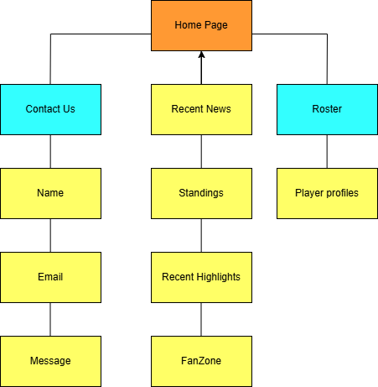

# Website Layout:

## Contact Us:

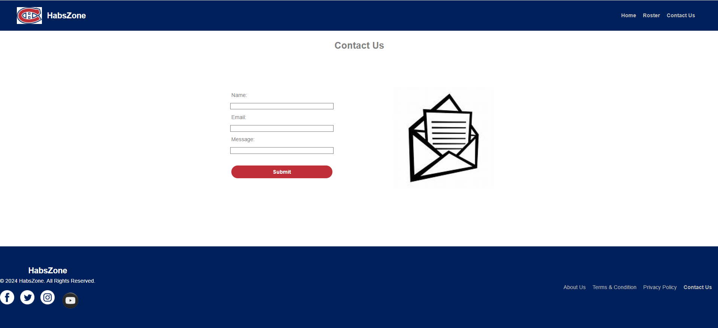

## Home:

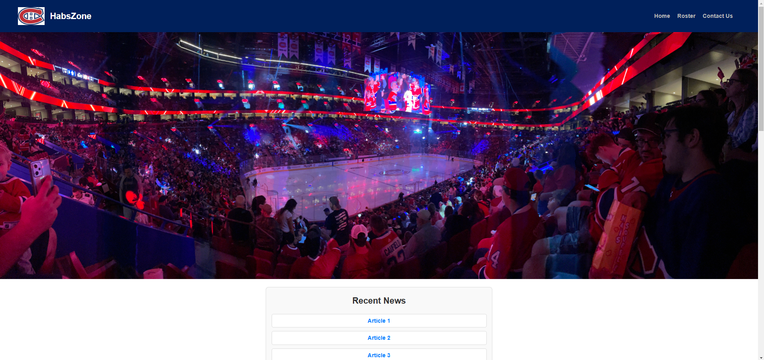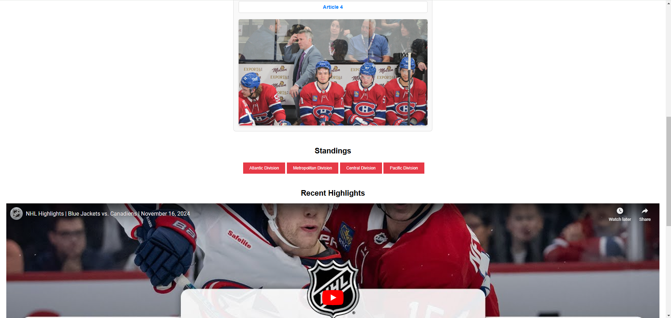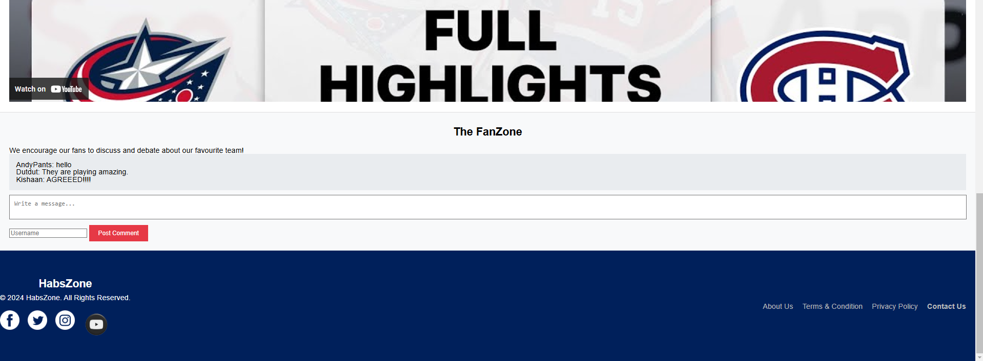

## Roster:

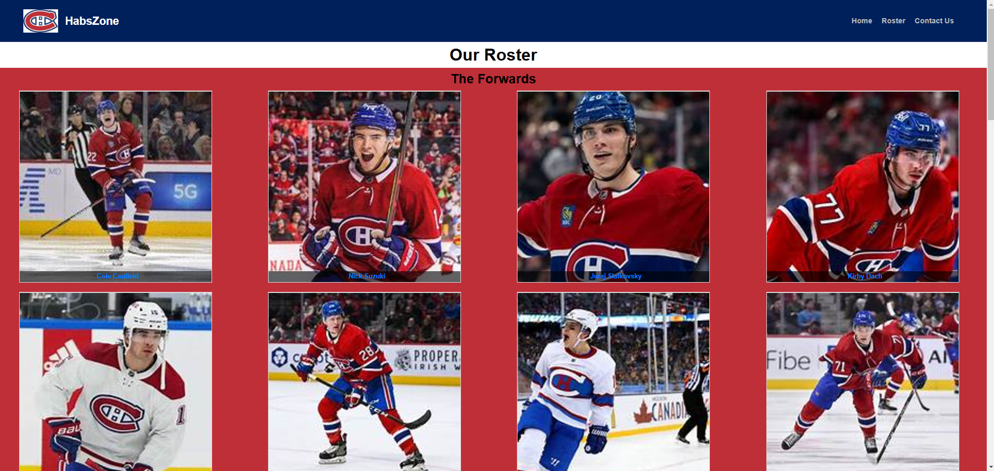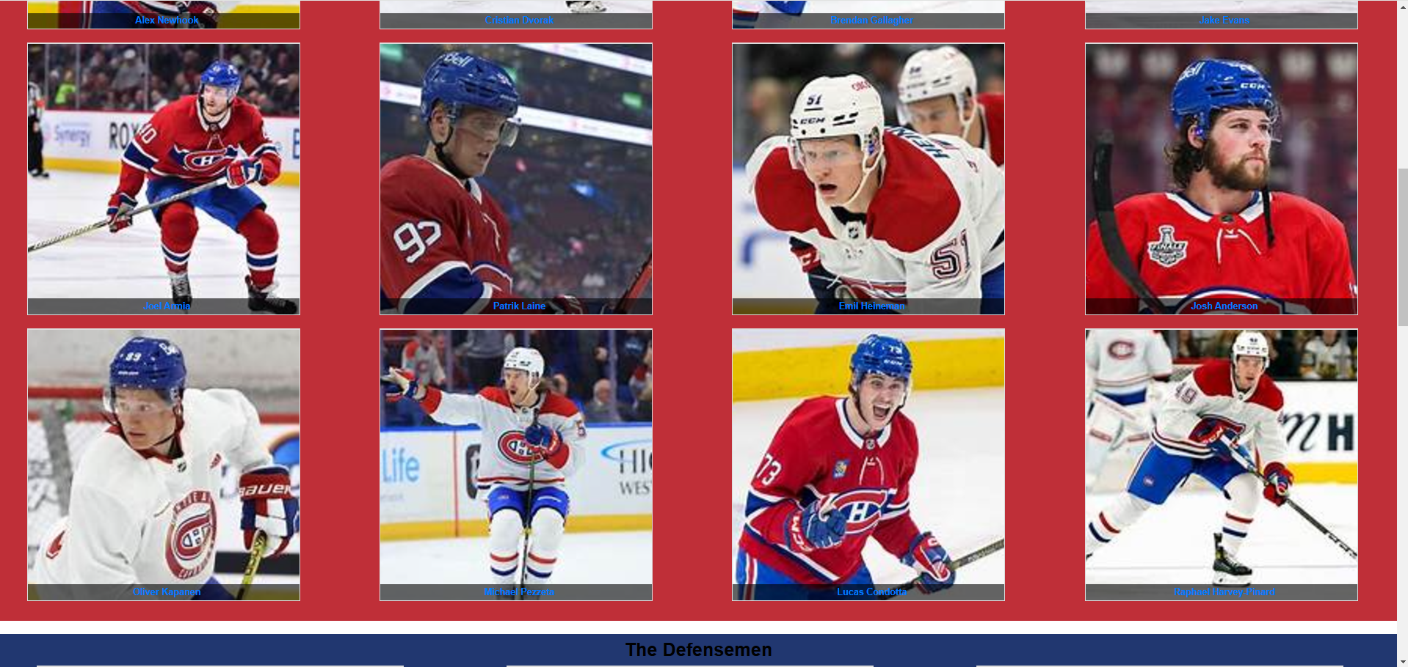

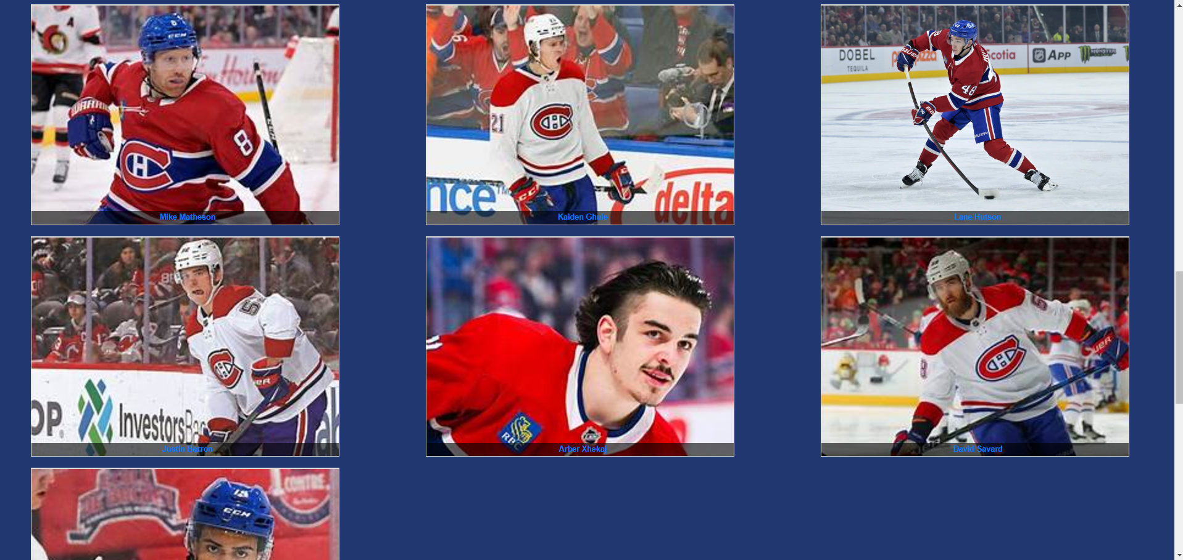

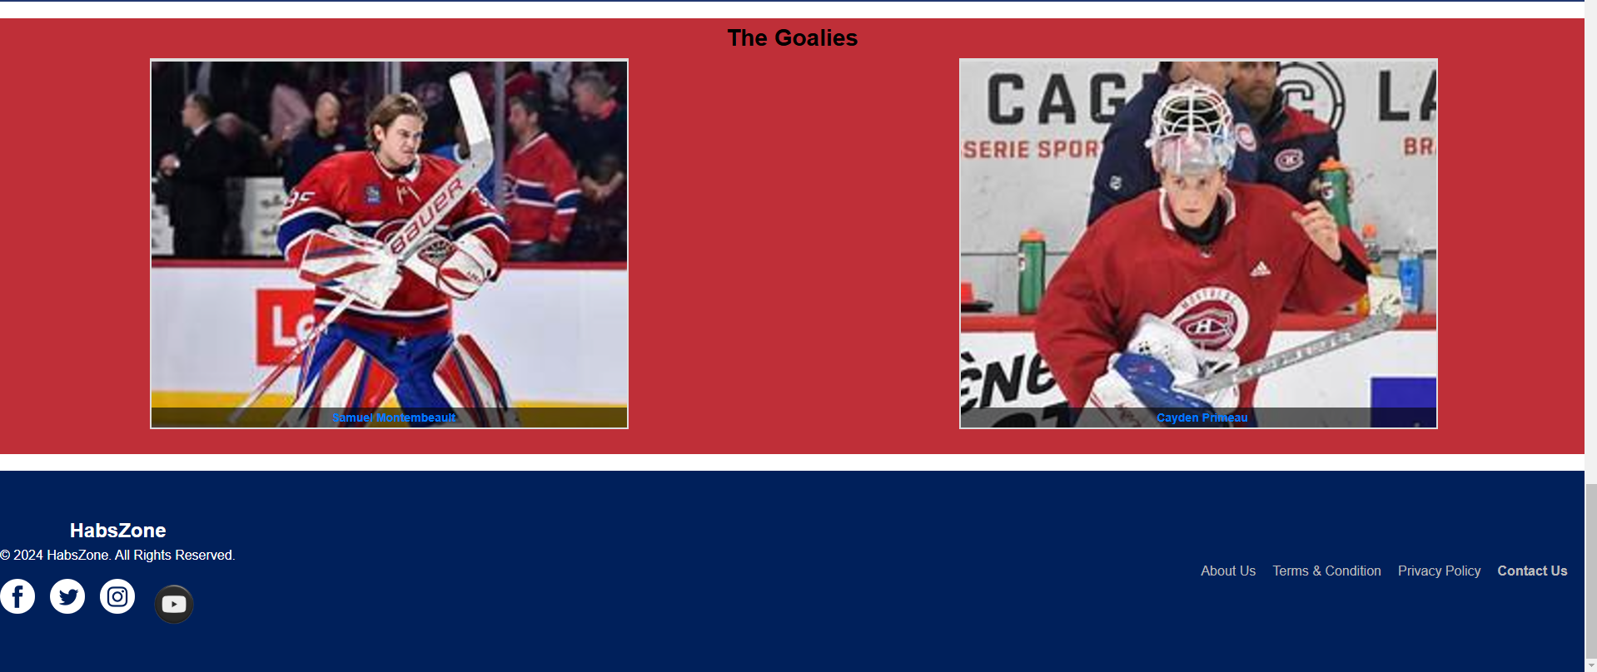

# Implementations Details:

## Home:

* **Header**: I used the logo and an unordered to make the menu at the top to go to the home, roster and contact us pages. I made the banner in its own div to take up the entire width of the page.
* **Recent news:** Used a container to center the section to the webpage. The news articles are in the container as well to help styling with the transition when hovering.
* **For the standings**, they are all 4 divisions in the NHL (Atlantic, Metropolitan, Central, and Pacific). I fetch the standings from a JSON file (Note: could not use an API because it is locked) and filter the teams by their division name. I get their position they are in by using the divisionSequence value from the JSON file and I store it all in a JQuery.
* **The recent highlights** are just an Iframe that links to a Habs game.
* **The FanZone** allows users to communicate by inserting their message and their username. The comments are saved to a JSON and then fetched by AJAX to display the comments in the comment form.
* **Footer:** contains a div of all the social media icons to style them into a row. The menu links at the bottom of the page do not function except for the contact link. The menu are in unordered list that are styled to be in a horizontal line.

## Roster:

* The webpage has 3 sections: **the forwards, the defensemen, and the goalies**, all containing different styles. All displaying different grid-templates.
* Used grids divs to make each player. Each player card contains the image and link to their stats on the NHL website.
* Made the background to follow the colour of the Canadiens’ home jersey (red, white, and blue).

## Contact Us:

* Created a form containing input texts for the user’s name, their email address, and their message. The form must be filled out to be submitted, and the email address is validated by checking the pattern in HTML and JavaScript.
* The submit button when clicked runs the submitForm function from the script.js that saves your name and email in a local storage by using DOM to get the element id of the name and email.

# GitHub:

<https://github.com/AndrewShahini/HabsZone>